PRESS RELEASE

COMMUNICATIONS AND MEDIA TEAM OF THE 43RD ASEAN SUMMIT 2023

No.15/SP/TKM-ASEAN2023/ENG/8/2023

43rd ASEAN Summit Venue JCC from Time to Time

Jakarta, 31 August 2023 – Roof of the building which lies in the center of Jakarta has a unique structure. It resembles an upside-down bowl; this roof made it easy for anyone to recall its name back in the 1980s. It is located not far from the Semanggi Bridge, the parliament complex, the headquarter of Indonesia’s Public Broadcasting Television Televisi Republik Indonesia (TVRI), and the Gelora Bung Karno Stadium complex. President Soekarno bestowed the name Balai Sidang Jakarta upon this building situated on a three-hectare land.

The Construction of the Balai Sidang Jakarta, along with several other buildings mentioned above, began on 8 February 1960. Initially, it was part of President Soekarno's grand plan to showcase Indonesia's strength and the splendor of Jakarta during the Developing Countries Sports Festival (Ganefo), an alternative multi-sport event surpassing the Olympics. This event was slated to be held from 10—22 November 1963.

However, according to historian Adolf Heuken, in his book "History of Jakarta in Paintings and Photos," Balai Sidang Jakarta failed to host the event because the construction has not completed. At that time, the construction cost amounted to US$12.5 million, approximately Rp187.5 billion.

Architect Soejoedi Wirjoatmodjo, who studied architecture in France, the Netherlands, and Germany, was selected to design and construct the building. According to Bagoes Wiryomartono in "Soejoedi and Architecture in Modern Indonesia," published in the “Journal of Architectural Research” on 6 June2016, Soejoedi was one of the post-independence Indonesian architects who laid the foundations of modernist design.

Soejoedi's modernist design was manifestation of his effort to break away from the colonial architectural style that still remained clearly apparent in many old buildings in the country. He also designed several iconic buildings in the early 1960s, including the Parliament Building, the ASEAN Secretariat Building, the Agriculture Ministry Building, the Manggala Wanabhakti Building, the Transportation Ministry Building, and several Indonesian Embassies, including those in Kuala Lumpur and Colombo.

Balai Sidang Jakarta was finally completed in 1974 with the Plenary Hall, a large auditorium with a seating capacity of 5,000 people. This auditorium is covered by a giant dome roof as mentioned previously. The building was immediately used for the 23rd Pacific Asia Travel Association (PATA) conference in April 1974. This 23rd PATA conference marked the beginning of Balai Sidang Jakarta to be known as the largest convention center in the country at the time.

Non-Aligned Movement Summit

Balai Sidang Jakarta underwent major renovations after Indonesia was selected to host the 10th Non-Aligned Movement Summit in 1992. This was carried out to accommodate a large event which invited 62 leaders and heads of Non-Aligned member states along with delegates from 109 countries. Second President of the Republic of Indonesia Soeharto inaugurated the new face of the Balai Sidang Jakarta, 25 August 1992 or 31 years ago.

After the renovation, Balai Sidang Jakarta had 13 meeting rooms of various sizes. The land area also expanded to 12 hectares after the renovation. Apart from the Plenary Session Room, there is also a 3,921 square meters meeting room that can accommodate 4,500 people. There is also the Cendrawasih Room covering an area of 2,109 square meters and 10 other rooms that can accommodate between 20 to 1,000 people.

An underground tunnel was built connecting the convention center with a nearby large hotel. This underground corridor is also equipped with a travelator. After the renovation, the name was changed to Jakarta Convention Center (JCC).

As quoted from the management’s website, the renovation resulted in the JCC having two large exhibition halls, namely Exhibition Hall A and B, which cover 3,060 square meters and 6,075 square meters respectively. These halls are connected by a corridor or foyer of about 450 square meters. After the 10th Non-Aligned Movement Summit, JCC’s popularity known by a convention venue.

As of today, the venue has hosted 30,000 events, ranging from college graduations, national and international meetings, to exhibitions of crafts and automotive products. It also hosted music concerts of popular Indonesian and international artists, along with world-class jazz festivals. JCC management is now under the Jakarta Provincial Government.

When Indonesia hosted the 2018 Asian Games, several martial arts disciplines used JCC as the competition venue. When Istora Senayan underwent renovations for the 2018 Asian Games, the 2017 Indonesia Open badminton championship was held at JCC.

The 43rd ASEAN Summit

JCC will once again host a large event, the 43rd Association of Southeast Asian Nations (ASEAN) Summit on 5—7 September 2023

On 13 January 2023, President Joko Widodo made a visit to JCC and inspected the facilities that will be used for the summit. After the visit, it was decided that the JCC would undergo further beautification in preparation for the ASEAN Summit.

Preparations were made, and a budget of Rp115.88 billion was allocated to refresh and improve the venue’s look. Moreover, according to the Foreign Minister, Retno Marsudi, delegates from 22 countries and nine international organizations will be present.

Aside from building renovations, improvements also included the landscaping and parking facilities for VVIPs. The beautification efforts extended to the interior as well, with the main design concept adopting elements of traditional Indonesian culture, with the involvement of Yori Antar, who is known as an Indonesian Architecture Warrior. This senior architect from the Han Awal design house is renown for his architectural designs with strong traditional cultural nuances combined with modern technology as seen in several tourist destinations in the country.

Ministry of Public Works and Public Housing’s (PUPR) Director General of Human Settlements (Cipta Karya) Diana Kusumastuti explained that the renovation reflects the character and identity of Indonesia as a nation. “We have added elements that depict the diversity of Indonesia. For example, we are adding synthetic rattan ornaments, padded walls, and new carpets,” said Diana.

The renovation process began on 23 June 2023 and divided into four zones, starting from the lower part of the JCC known as the Lower Ground up to the Ground Floor. All 13 meeting rooms are to be beautified, and the appearance and facilities of all restrooms are renewed. The underground tunnel will also be renovated to allow delegates to pass through it comfortably during the summit.

Renovation works also include the prayer room of JCC to make it more comfortable for worship. The main waiting area for VVIPs or the presidential area is also included in the renovation plan. In the final zone, the PUPR Ministry will renovate the exterior of JCC, which will be a reception area for visiting foreign dignitaries. The works in the exterior area include installing a large canopy, arranging the drop-off area, front and side gardens, and constructing a prayer room outside the main building.

The surrounding area of Balai Sidang also received attention, including the quality improvement or road preservation within the complex of Gelora Bung Karno Stadium with an area of approximately 4.67 kilometers with a budget of nearly Rp30 billion. When President Joko “Jokowi” Widodo made another inspection on Monday (14 August 2023), PUPR Minister Basuki Hadimuljono assured that the renovation project will be completed on schedule.

Meanwhile, PT Wijaya Karya, Tbk has carried out the Provisional Hand Over (PHO) to the PUPR Ministry for the Jakarta Convention Center (JCC) Rehabilitation project located in the Gelora Bung Karno Area, Jakarta.

The handover was carried out by WIKA's Senior Vice President Building and Overseas Division Muchamad Yusuf to the Contract Signing Officer for Building Arrangement I at the Work Unit for Implementation of Settlement Infrastructure for the Jakarta Metropolitan Area of the Ministry of PUPR Grace Christiani in Jakarta, Friday (25/8/2023).

WIKA completed the project in just 72 days or faster than the government's target of 105 days. "After this, WIKA will focus on maintenance while at the same time ensuring the quality and safety of the building," said WIKA Main Director Agung Budi Waskito in a written statement, Tuesday (29/8/2023). (Anton Setiawan/Donna/Elvira Inda Sari)

For more information, please contact:

Director General of Public Information and Communications of the Ministry of Communication and Informatics – Usman Kansong (0816785320)

Get more information at http://asean2023.id, https://infopublik.id/kategori/asean-2023, dan https://indonesia.go.id/kategori/ragam-asean-2023

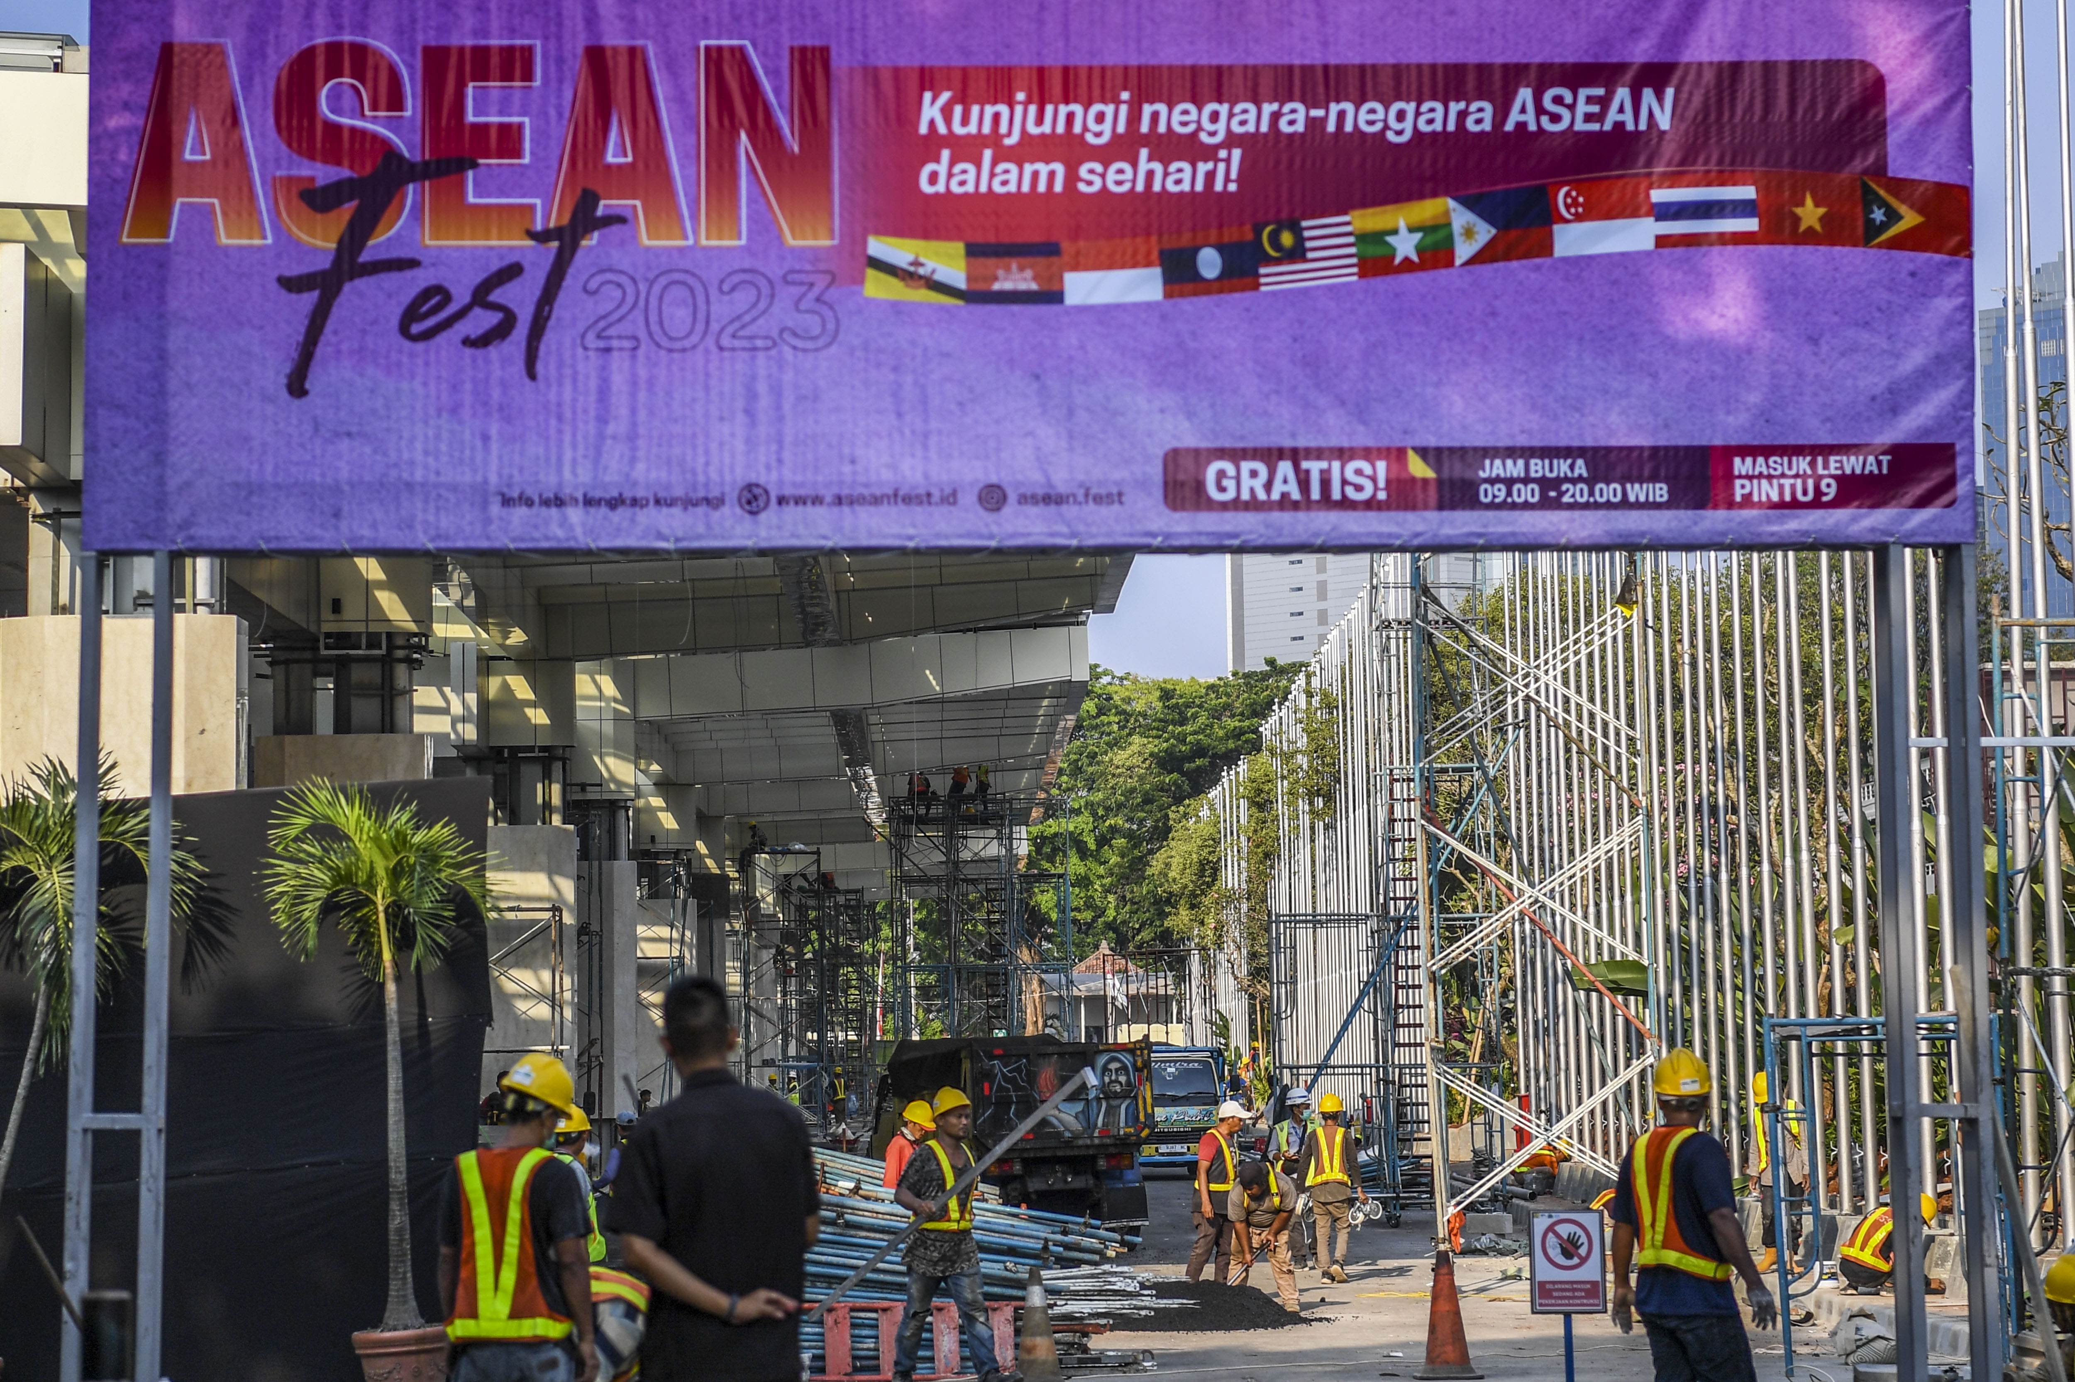

A number of construction workers complete the renovation of the Jakarta Convention Center (JCC) for the 43rd ASEAN Summit 2023 in Jakarta, Wednesday (23/8/2023). The series of agenda for the 43rd ASEAN Summit 2023 in Jakarta will take place from 5—7 September 2023, and will be held at the JCC, Jakarta. ANTARA PHOTO/Galih Pradipta/hp

